‘Vermiculite no 5’ **grinded**. Size of particles similar to those of Na-Fh.

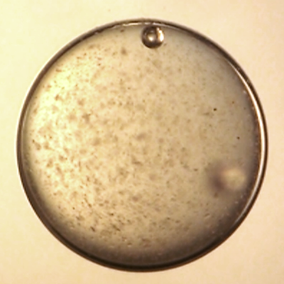 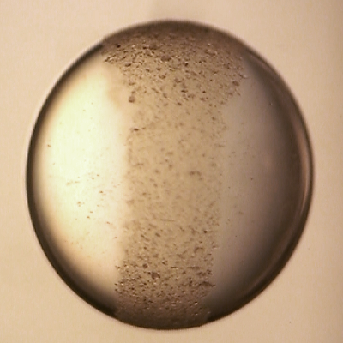 FRONT VIEW

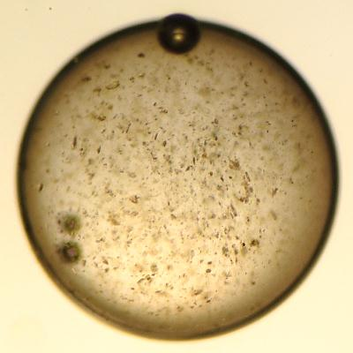 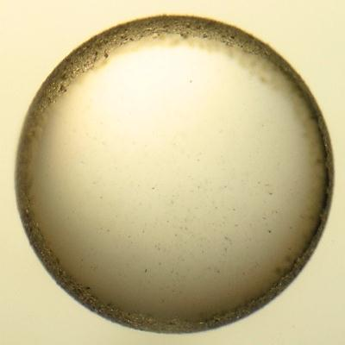 SIDE VIEW (along E-field lines)

0 min 5 min (at ~200 V/mm)

BEHAVES SIMILARLY TO NA-FH or Lp

‘Vermiculite no 5’ **chopped** mixed with **grinded**.

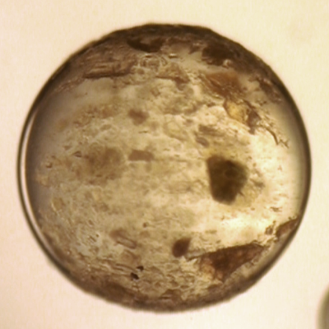 FRONT VIEW

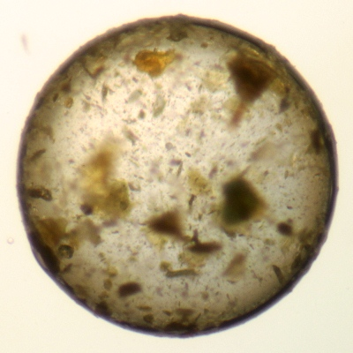 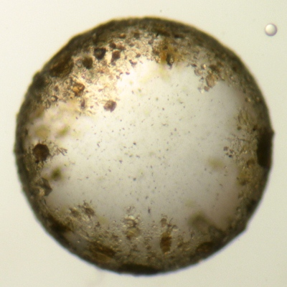 SIDE VIEW (along E-field lines)

0 min 5 min (at ~200 V/mm)

BEHAVES SIMILARLY TO those chopped Na-FH that you though was VERMICULITE